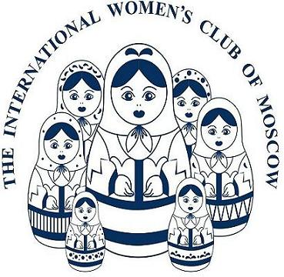

Public Relations Chair
The PR Chair promotes the IWC and its fundraising events both inside and outside the Club. The PR team is responsible for maintaining and establishing contacts with other international organizations and various media partners. Basic knowledge of MS Word and e-mail are needed as well as good communication skills.

